|  |  |
| --- | --- |
|  | **MINISTRY OF EDUCATION AND TRAINING** |



**CAPSTONE PROJECT DOCUMENT**



**HOME SURVEILANCE SYSTEM**

Members: Truong Van Cuong

Dinh Tru Ngoc Diep

Vo Tuan Hung

Dinh Thanh Dung

Supervisor: PhD. Phan Duy Hung

Project Code: HSS

**Hanoi, April 20th, 201****6**

**TABLE OF CONTENT**

**DEFINITION AND ACRONYMS**

**CHAPTER 1 - INTRODUCTION**

**1.1. Project Information**

* Project name: Home Surveillance System
* Project code: HSS
* Project group name: HSS4T
* Product type: Embedded system and Android application
* Timeline: Jan 4th, 2016 to April, 2016

**1.2. The people**

**1.2.1. Supervisor**

|  |  |  |  |
| --- | --- | --- | --- |
| Full Name | Email | Phone | Title |
| Phan Duy Hung | hungpd@fpt.edu.vn | 0975597339 | Lecturer |

**1.2.2. Team members**

|  |  |  |  |  |  |
| --- | --- | --- | --- | --- | --- |
| # | Full Name | ID | Email | Phone | Role |
| 1 | Truong Van Cuong | SE03155 | cuongtvse03155@fpt.edu.vn | 0989656508 | Leader |
| 2 | Dinh Tru Ngoc Diep |  |  | 0935025666 | Member |
| 3 | Vo Tuan Hung |  |  | 01684848037 | Member |
| 4 | Dinh Thanh Dung |  |  | 0977369129 | Member |

**1.3. Background**

The field of the Internet of Things (IoT) is based on the standard of supporting the Internet protocol to all limits of the Internet and on the fact that at the edge of the network, many small devices are still unable to support IP protocol stacks. The increase of Internet’s role in home computerization has primarily come about due to the networked natured of deployed electronics where electronic devices (even not an e. device) becoming part of smart home’s overall architecture.

There is a growing interest in intelligent home network as a way of offer a comfortable, convenient and safe environment for occupants. IoT applications using sensors to gather information about operating environment combined with cloud hosted analytics software that examine disparate data points will help skill managers become more proactive.

**1.4. Idea**

We are referring to the keyword ‘Smart Home’, and in this capstone project it’s ‘Home Surveillance System’ in details. Nowadays, mobile devices like smartphones or tablets are being used to handle daily tasks that traditional desktop and laptop computer once handled. These changes have given rise to the development of several home surveillance technologies and systems. Surveillance system can be defined as monitoring of the behavior, other changing information, activities, observing or analyzing particular area for the purpose of influencing, directing, managing or protecting. Remotely controlled systems use an Internet connection to allow the user complete control of their system from their mobile devices.

Some people will ask a why question: Why mobile devices like smartphones or tablets but laptop or desktop computer, even they also can connect to internet. According to a reliable study of Morgan Stanley from Technology & Internet Trends, “91% of people keep their phone within 3 feet 24 hours a day”. So the matter here is focusing into user’s habits and demands.

**1.5. Proposal of system**

**1.5.1. The scope**

Home Surveillance System (HSS) in this project is a prototype of comprehensive solution for home surveillance problems in modern life. Demo for this HSS is limit in one room in typical house. It includes hardware and software that must be satisfied below specifications:

Hardware:

* All components are connected and work well with hub
* All components work in real-time, process data/signal exactly and quickly
* Hub sends notifications to Android application (even application is not running in background)
* Can deploy immediately in members’ house after finishing this project

Software:

* Support Android 4.1 and higher
* Have login mechanism to initiate connection between hub and application (authenticating and authorizing)
* Using internet connection (Cellular data/Wifi) for
  + Activate/deactivate entire system or a particular device remotely
  + Monitoring and tracking activities in house remotely
* Receive notifications immediately (real-time) when there are suspect activities in house (system is activated) and show them to smartphone
* Make an emergency dial to particular phone number

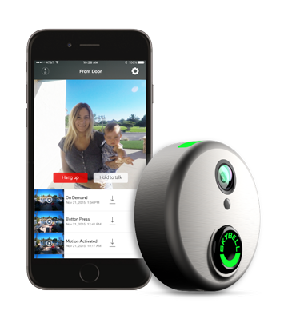**1.5.2. Existing System**

**SkyBell**

SkyBell is a smart video doorbell that allows you to see, hear, and speak to the visitor at your door whether you’re at home, at work, or on the go. SkyBell gives you the control, convenience and safety you've never had before. Whether you're home or away, feel confident knowing you can see who's at your door! Of course, you would receive the notifications when someone pressing the doorbell on your smartphone.

**IDEAL Security System**

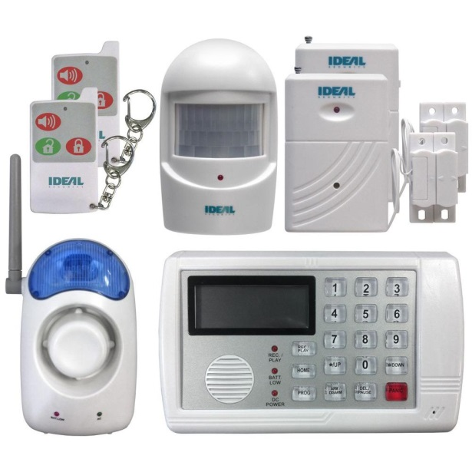Wireless, Self Monitoring Home Security System with Telephone Dialer. The SYSTEM that calls you. No monitoring fees. Our Wireless Alarm System allows you to create your own security system. When the AUTO DIALER is connected to a telephone land line, an electrical outlet and set to ARM mode it will alert you when any of the sensors have been triggered. The auto-dialer will activate the siren or chime and dial out to up to 5 pre-programmed telephone numbers with your own pre-recorded message. You can choose to remotely listen in & broadcast to the protected areas. Includes 2 wireless door and window contacts, 1 motion sensor, 2 remote controls, 1 wireless siren and a telephone dialer. All items are pre-connected to the dialer. Set includes all telephone connections, batteries, AC adapter and instructions. Land phone connection for dialer is required. System can call cell or land phones. Customize a system suited to your needs by adding a wide range of Ideal wireless accessories.